**Assignment No:-14**

Name:-Suryawanshi Sangramsingh Sambhaji

Batch: - Delta - DCA (Java) 2024 Date:-21/5/2024

**1. Write a program enter an array and find the sum and count of element present at even position.**

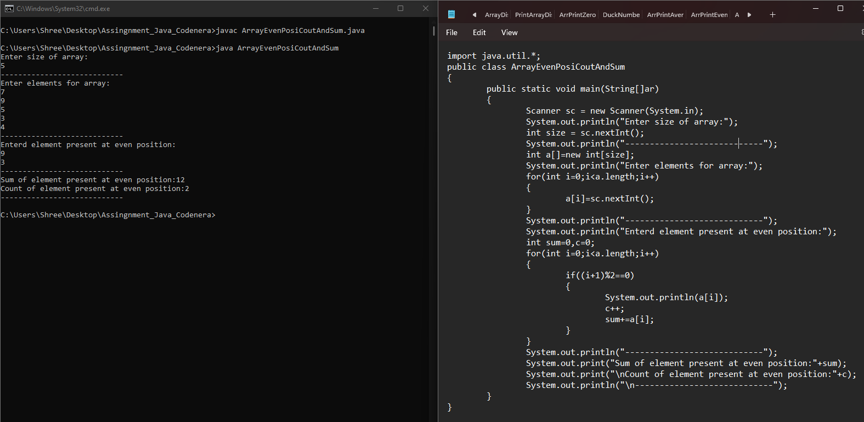

**2. Write a program enter an array and find the sum and count of odd element.**

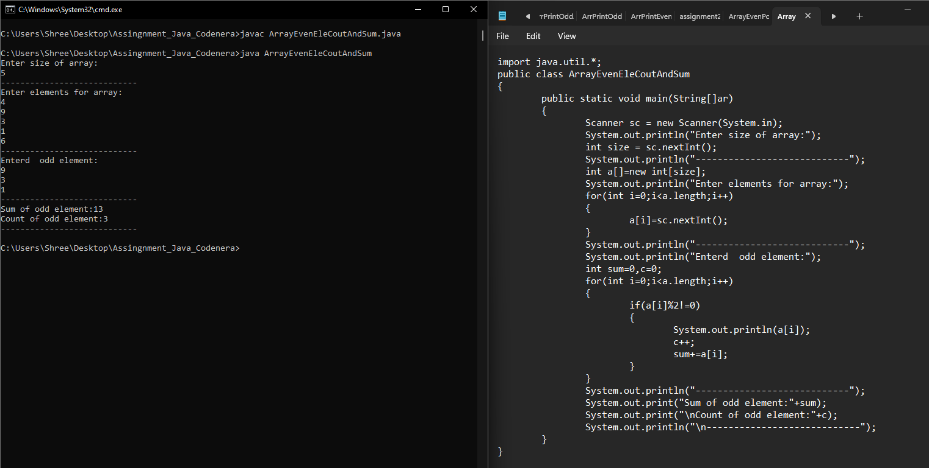

**3.** **Write a program to replace all the 0’s with 1’s in your array. Your array is [26, 0, 67, 45, 0, 78, 54, 34, 10, 0, 34].**

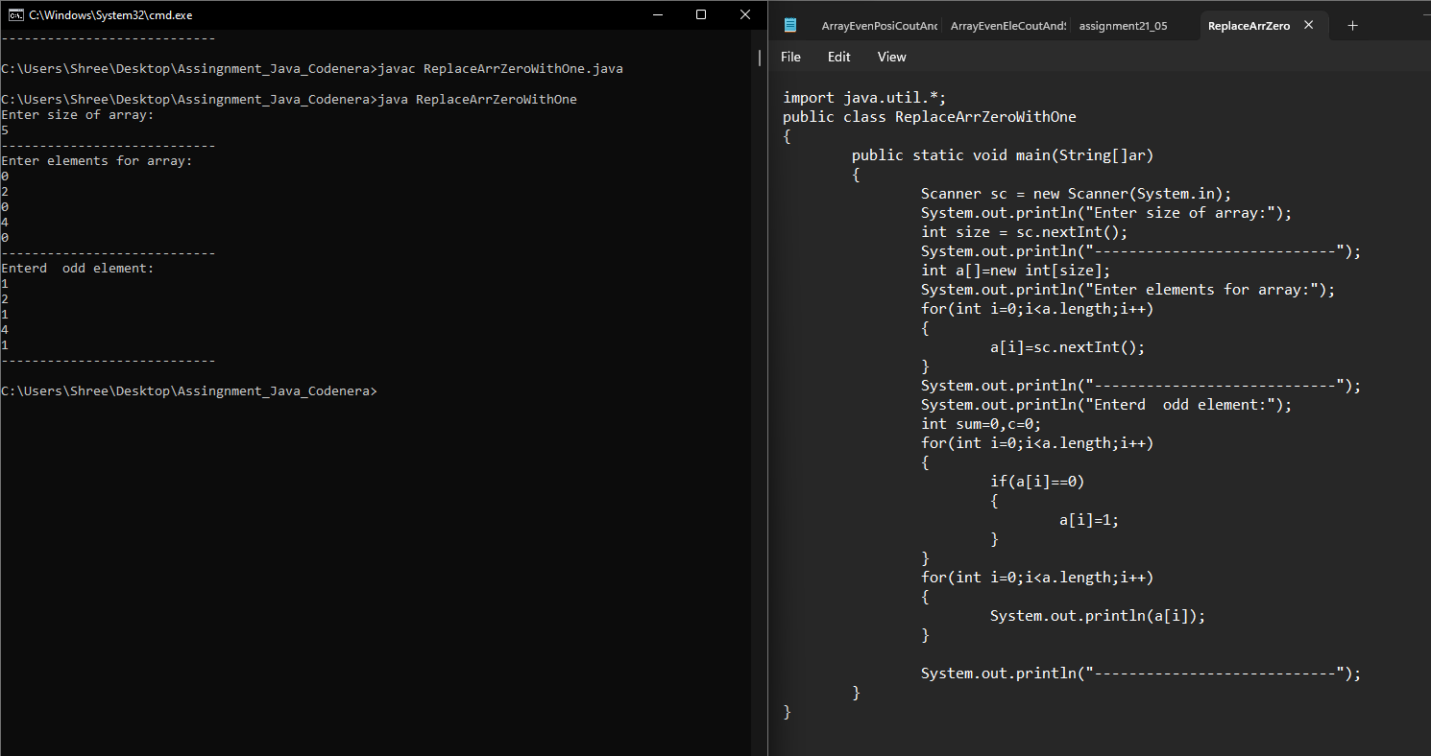

**4. Write a program enter an array and search any particular element.**

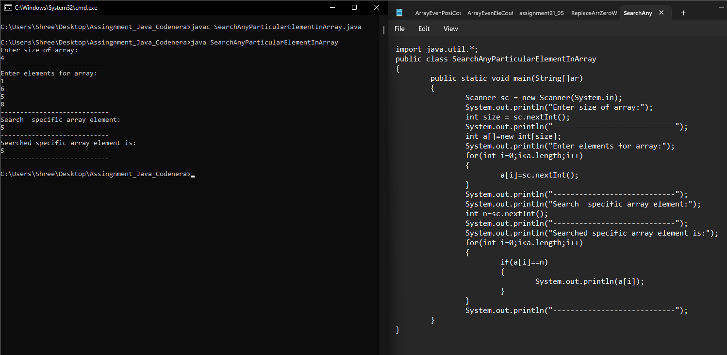

**5.** **Write a program to check if an array of integers contains two specified elements.**

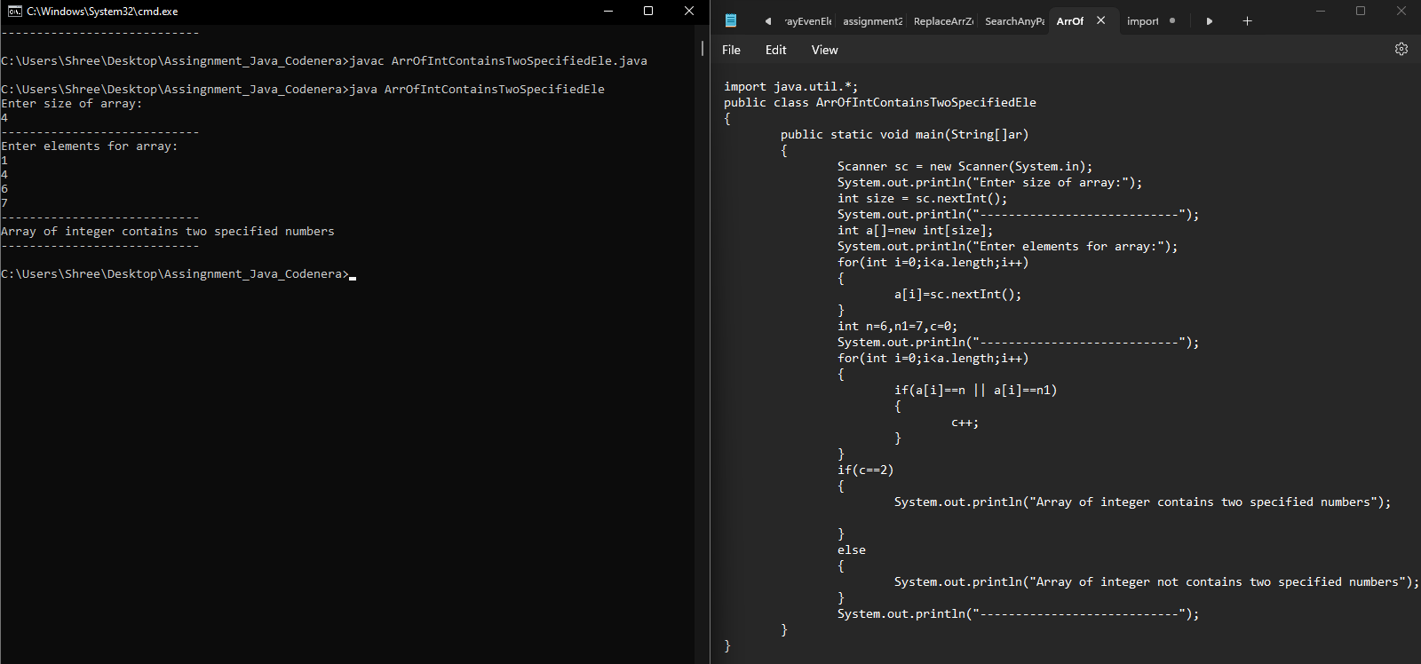

**6.** **Write a program input 10 elements and multiply 5th elements by 25.**

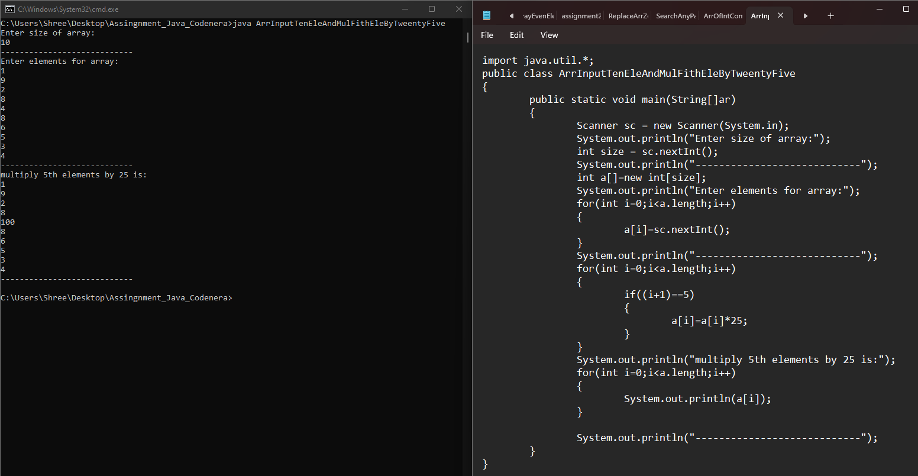

**7.** **Write a program enter an array and print the square of the element which is on odd position.**

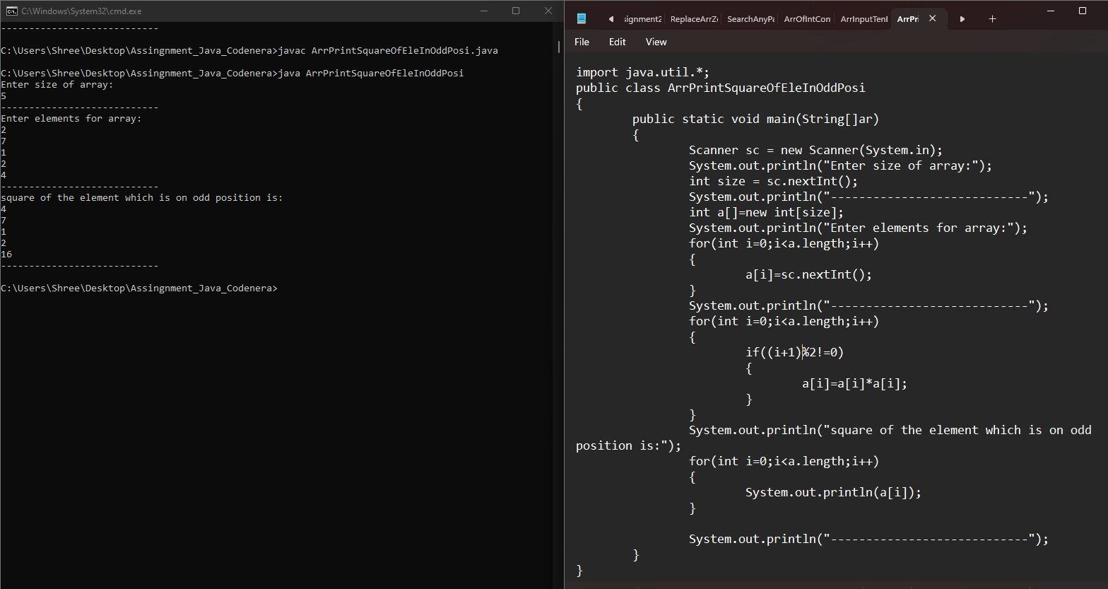

**8. Write a program enter an array and print the square of the element which is on even position.**

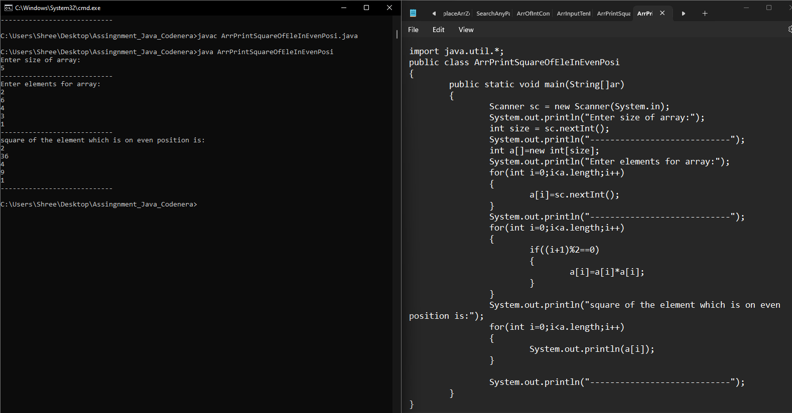

**9. Write a program replace all negative value with its immediate left elements square. Means arr[] = [12, 3, -19, 29, 5, -61, 44, 7, -9] Output array will be [12, 3, 9, 29, 5, 25, 44, 7, 49].**

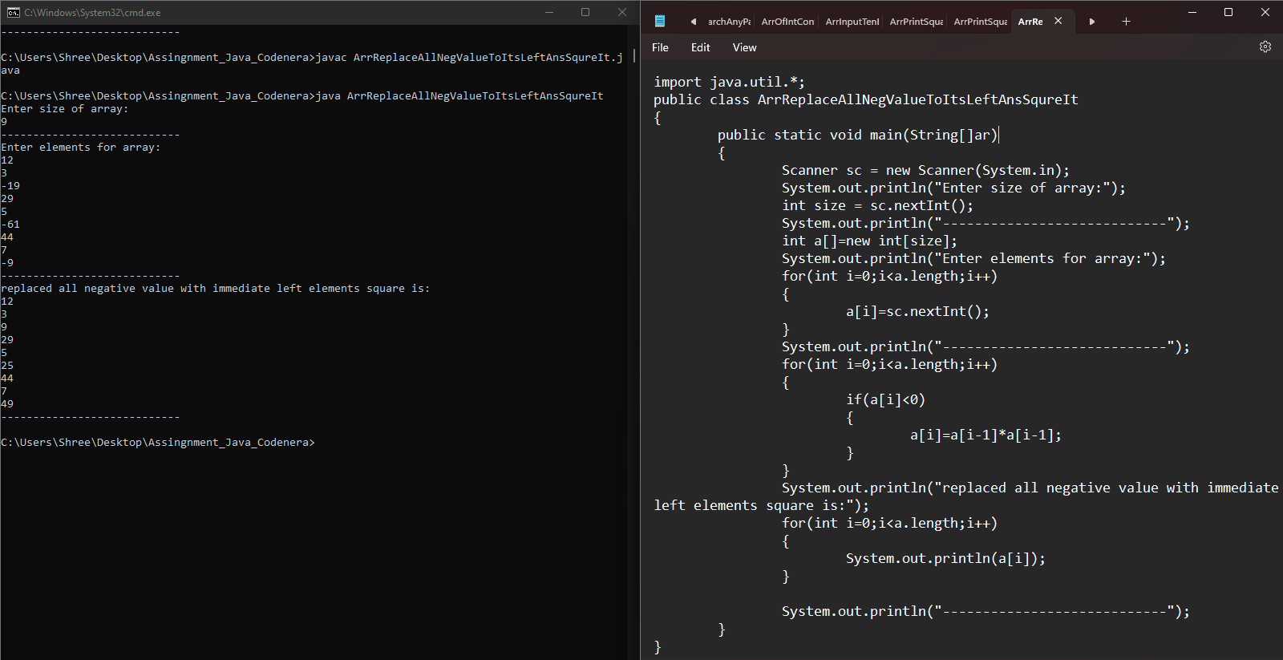

**10. Write a program to input an array and find its average of first 5 element.**

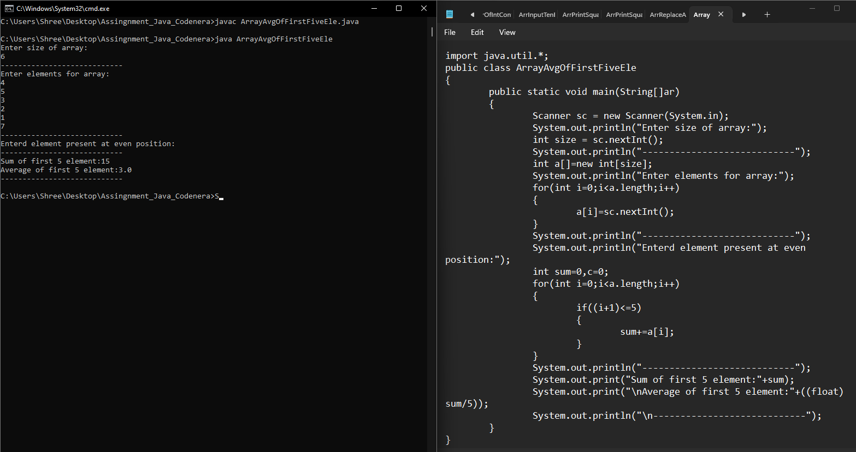

**11. Write a program enter an array and find the sum of 1st and last element in the given array.**

